**Expandable Section View**

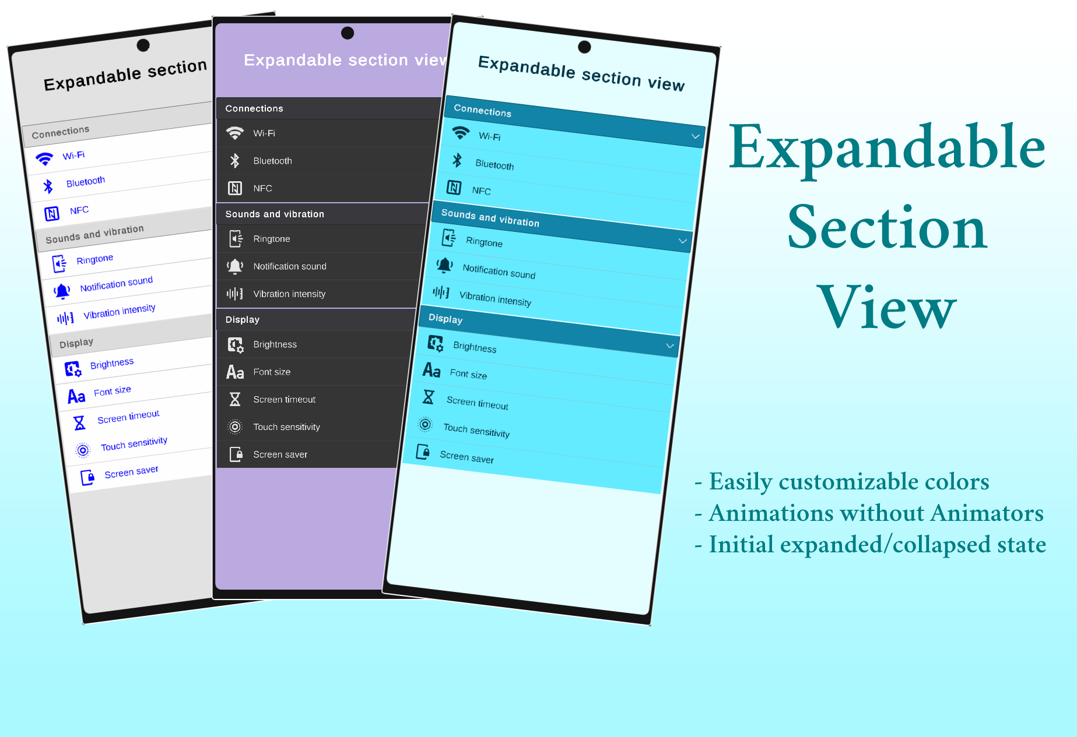

# Table of contents:

**Modify the colors** **3**

**Add a new section** **5**

**Add a new item in section** **6**

**Choose the initial state** **7**

# 

# Modify the colors

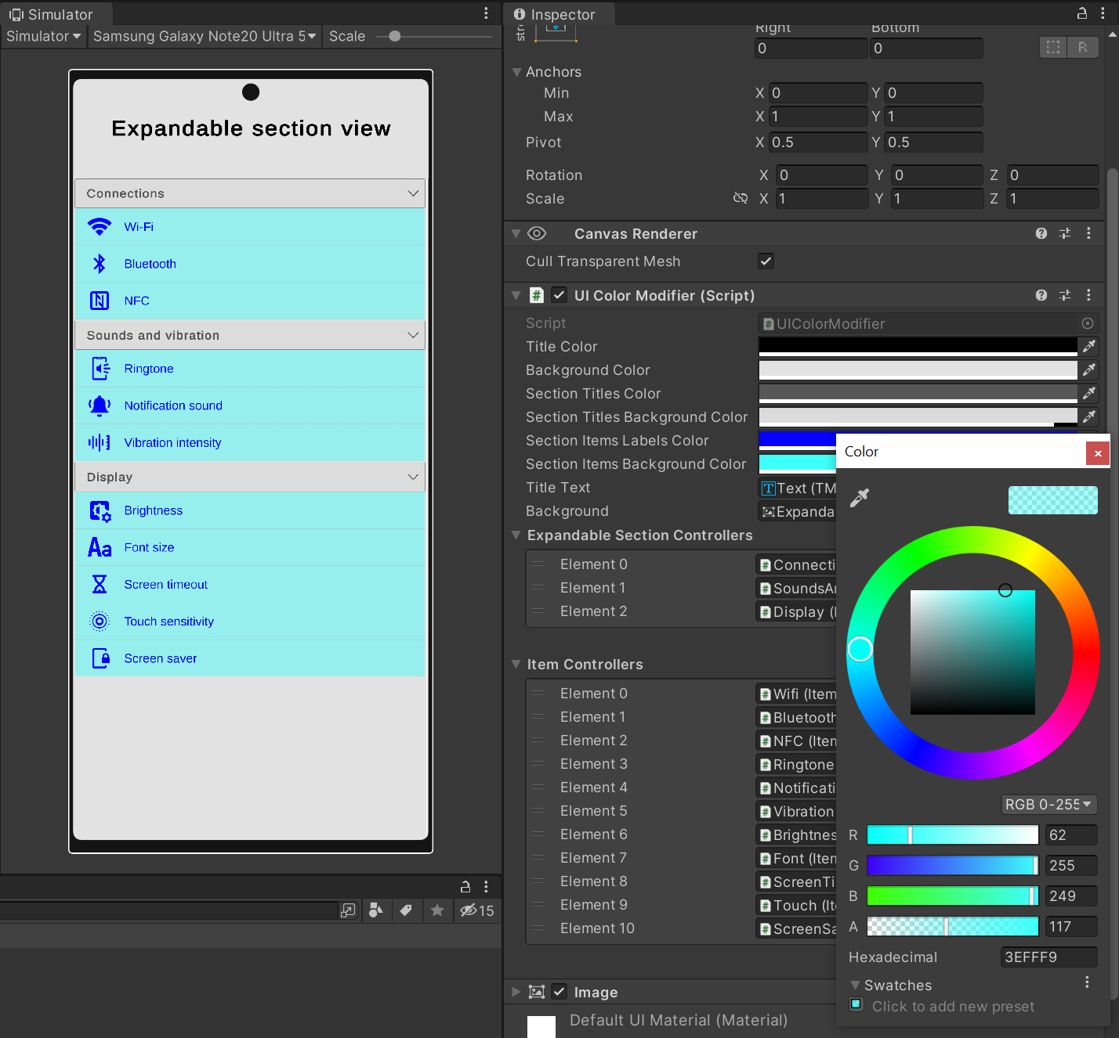

To modify the colors, open **Prefabs > ExpandableSectionView**. The root element contains a script **UI Color Modifier** with multiple colors at the top. Modify any of the colors - the prefab should change.

# Add a new section

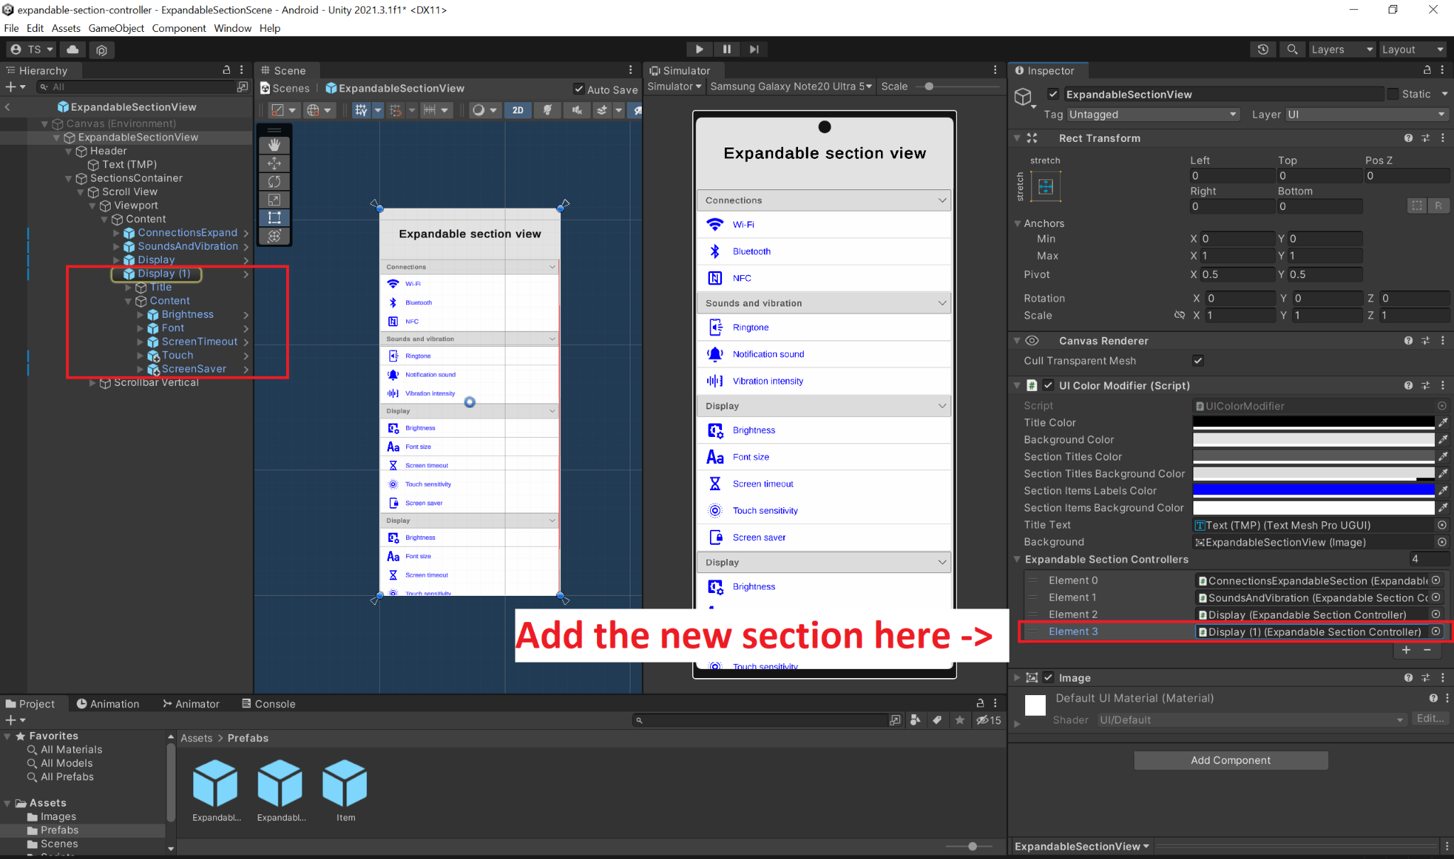

To add a new section, open **Prefabs > ExpandableSectionView**. Expand the elements as shown in the screenshot. Expand **Content** and duplicate some of the items. The section should show.

You should now attach it to the **UI Color Modifier** in the root element, as shown above**.**

# Add a new item in the section

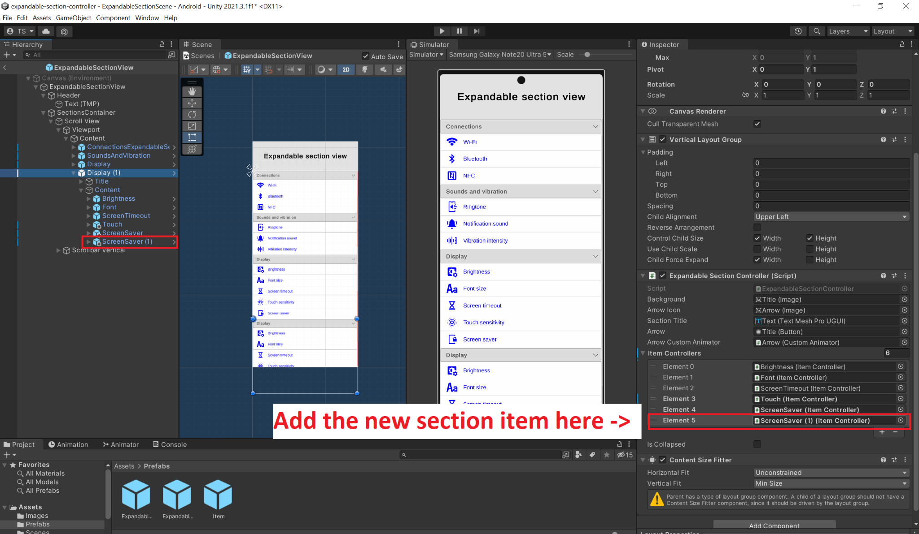

To add a new item, expand the required section in the prefab. Duplicate some of the elements and modify the values as you wish. You should now attach it to the **Expandable Section Controller,** as shown in the screenshot.

# Choose the initial state

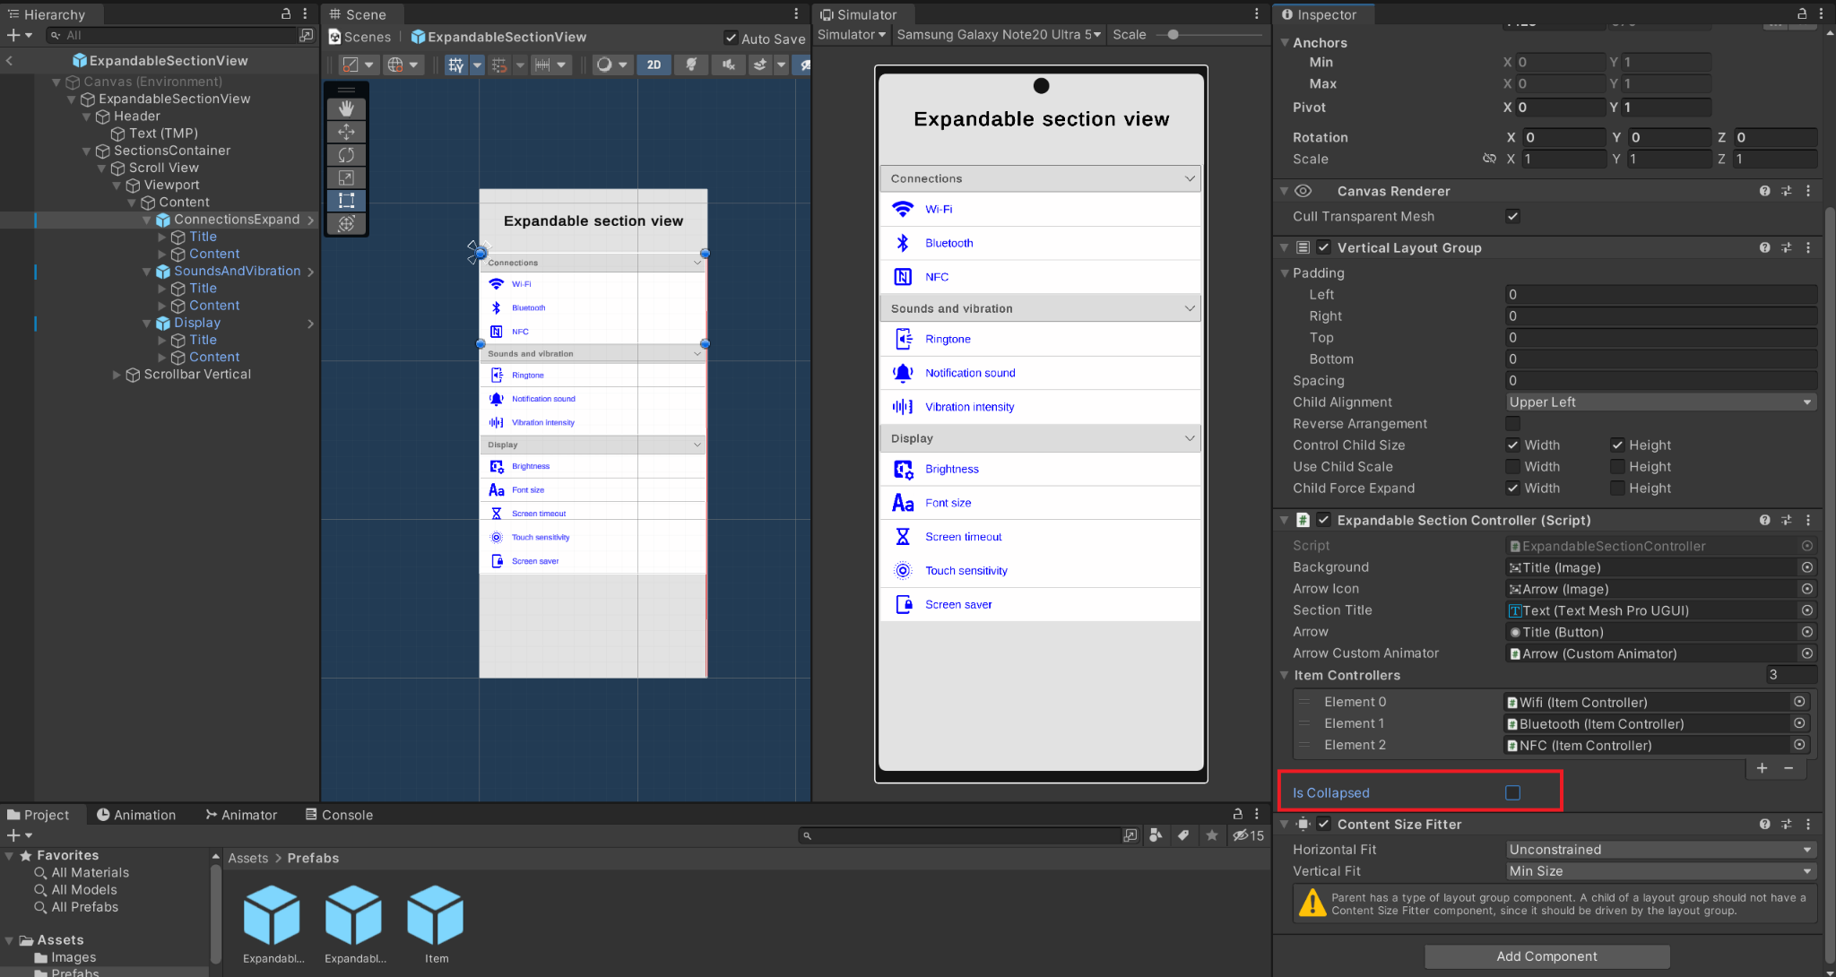

To choose the initial state of each section, find the **Expandable Section Controller,** attached to the section UI element and check/uncheck **Is Collapsed**, as shown above.